MACHINE LEARNING LAB

ASSIGNMENT-1

Tulasi Sai Tharun Peram

AP20110010801

CSE-L

Introduction to Python Basics

Exercise_1_10_02_23

1. **Write a Python program to print the following string in a specific format (see the output).**

**CODE: -**

print("Twinkle, twinkle, little star, \n\tHow I wonder what you are! \n\t\tUp above the world so high, \n\t\tLike a diamond in the sky. \nTwinkle, twinkle, little star, \n\tHow I wonder what you are!")

print("\n Tharun Peram, AP20110010801")

**Screenshot of OUTPUT: -**

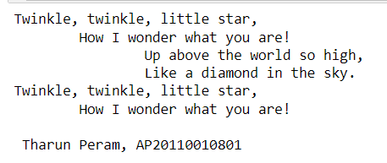

1. **Write a Python program to find out what version of Python you are using.**

**CODE: -**

import sys

print("Python version")

print (sys.version)

print("Version info.")

print (sys.version_info)

print("\n Tharun Peram, AP20110010801")

**Screenshot of OUTPUT: -**

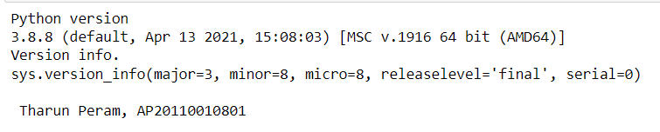

1. **Write a Python program to display the current date and time.**

**CODE: -**

from datetime import date

today = date.today()

print("Today's date:", today)

print("\nTharun Peram, AP20110010801")

**Screenshot of OUTPUT: -**

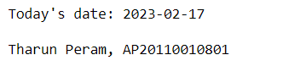

1. **Write a Python program that calculates the area of a circle based on the radius entered by the user.**

**CODE: -**

r = float(input())

area = (3.14*(r*r))

print(area)

print("\nTharun Peram, AP20110010801")

**Screenshot of OUTPUT: -**

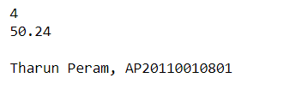

1. **Write a Python program that accepts the user's first and last name and prints them in reverse order with a space between them.**

**CODE: -**

firstname = input()

lastname = input()

print(lastname,firstname)

print("\nTharun Peram, AP20110010801")

**Screenshot of OUTPUT: -**

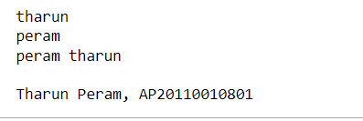

1. **Write a Python program that accepts a sequence of comma-separated numbers from the user and generates a list and a tuple of those numbers**

**Sample data : 3, 5, 7, 23**

**Output :**

**List : ['3', ' 5', ' 7', ' 23']**

**Tuple : ('3', ' 5', ' 7', ' 23')**

**CODE: -**

values = input()

list = values.split(",")

Tuple = tuple(list)

print("List:",list)

print("Tuple:",Tuple)

print("\nTharun Peram, AP20110010801")

**Screenshot of OUTPUT: -**

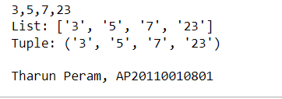

1. **Write a Python program that accepts a filename from the user and prints the extension of the file.**

**CODE: -**

filename = input()

f_extns = filename.split(".")

print ("" + repr(f_extns[-1]))

print("\nTharun Peram, AP20110010801")

**Screenshot of OUTPUT: -**

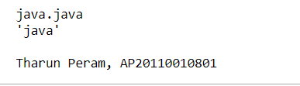

1. **Write a Python program to display the first and last colors from the following list.**

**CODE: -**

color_list = input()

order = color_list.split(",")

print( "%s %s"%(order[0],order[-1]))

print("\nTharun Peram, AP20110010801")

**Screenshot of OUTPUT: -**

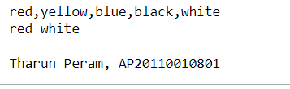

1. **Write a Python program to display the examination schedule. (extract the date from exam_st_date).**

**CODE: -**

exam_st_date = (11,12,2022)

print( "The examination will start from : %i / %i / %i"%exam_st_date)

print("\nTharun Peram, AP20110010801")

**Screenshot of OUTPUT: -**

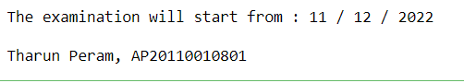

1. **Write a Python program that accepts an integer (n) and computes the value of n+nn+nnn.**

**CODE: -**

n = input()

n1 = n+n

n2 = n+n+n

a = int(n)+int(n1)+int(n2)

print(a)

print("\nTharun Peram, AP20110010801")

**Screenshot of OUTPUT: -**

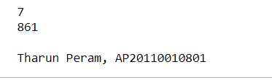

1. **Write a Python function that takes a sequence of numbers and determines whether all the numbers are different from each other.**

**CODE: -**

def test_distinct(data):

if len(data) == len(set(data)):

return True

else:

return False;

print(test_distinct([1,2,3,4,5])) #True

print(test_distinct([1,2,2,3,4,5,6,7,8])) #False

print("\nTharun Peram, AP20110010801")

**Screenshot of OUTPUT: -**

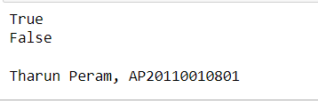

1. **Write a Python program that creates all possible strings using the letters 'a', 'e', 'i', 'o', and 'u'. Ensure that each character is used only once.**

**CODE: -**

import random

char_list = ['a','e','i','o','u']

random.shuffle(char_list)

print(''.join(char_list))

print("\nTharun Peram, AP20110010801")

**Screenshots of OUTPUT: -**

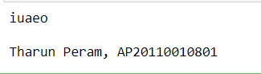

1. **Write a Python program that removes and prints every third number from a list of numbers until the list is empty.**

**CODE: -**

def remove_nums(int_list):

#list starts with 0 index

position = 3 - 1

idx = 0

len_list = (len(int_list))

while len_list>0:

idx = (position+idx)%len_list

print(int_list.pop(idx))

len_list -= 1

nums = [10,20,30,40,50,60,70,80,90]

remove_nums(nums)

print("\nTharun Peram, AP20110010801")

**Screenshot of OUTPUT: -**

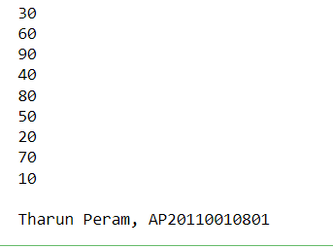

1. **Write a Python program to identify unique triplets whose three elements sum to zero from an array of n integers.**

**CODE: -**

def three_sum(nums):

result = []

nums.sort()

for i in range(len(nums)-2):

if i> 0 and nums[i] == nums[i-1]:

continue

l, r = i+1, len(nums)-1

while l < r:

s = nums[i] + nums[l] + nums[r]

if s > 0:

r -= 1

elif s < 0:

l += 1

else:

# found three sum

result.append((nums[i], nums[l], nums[r]))

# remove duplicates

while l < r and nums[l] == nums[l+1]:

l+=1

while l < r and nums[r] == nums[r-1]:

r -= 1

l += 1

r -= 1

return result

x = [1, -6, 4, 2, -1, 2, 0, -2, 0]

print(three_sum(x))

print("\nTharun Peram, AP20110010801")

**Screenshot of OUTPUT: -**

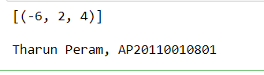

1. **Write a Python program to make combinations of 3 digits.**

**CODE: -**

a=int(input("Enter first number:"))

b=int(input("Enter second number:"))

c=int(input("Enter third number:"))

d=[]

d.append(a)

d.append(b)

d.append(c)

for i in range(0,3):

for j in range(0,3):

for k in range(0,3):

if(i!=j&j!=k&k!=i):

print(d[i],d[j],d[k])

print("\nTharun Peram, AP20110010801")

**Screenshot of OUTPUT: -**

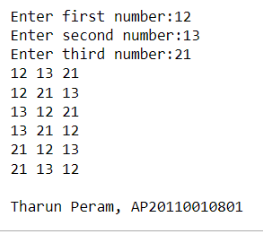

1. **Write a Python program that prints long text, converts it to a list, and prints all the words and the frequency of each word.**

**CODE: -**

string_words = '''Machine learning is a subfield of artificial intelligence, which is broadly defined as the capability of a machine

to imitate intelligent human behavior. Artificial intelligence systems are used to perform complex tasks in a way that is similar to

how humans solve problems.

The goal of AI is to create computer models that exhibit “intelligent behaviors” like humans, according to Boris Katz, a principal

research scientist and head of the InfoLab Group at CSAIL. This means machines that can recognize a visual scene, understand a text

written in natural language, or perform an action in the physical world.

Machine learning is one way to use AI. It was defined in the 1950s by AI pioneer Arthur Samuel as “the field of study that gives

computers the ability to learn without explicitly being programmed.”

The definition holds true, according toMikey Shulman, a lecturer at MIT Sloan and head of machine learning at Kensho, which

specializes in artificial intelligence for the finance and U.S. intelligence communities. He compared the traditional way of

programming computers, or “software 1.0,” to baking, where a recipe calls for precise amounts of ingredients and tells the baker

to mix for an exact amount of time. Traditional programming similarly requires creating detailed instructions for the computer to

follow.

But in some cases, writing a program for the machine to follow is time-consuming or impossible, such as training a computer to

recognize pictures of different people. While humans can do this task easily, it’s difficult to tell a computer how to do it.

Machine learning takes the approach of letting computers learn to program themselves through experience. '''

word_list = string_words.split()

word_freq = [word_list.count(n) for n in word_list]

print("String:\n {} \n".format(string_words))

print("List:\n {} \n".format(str(word_list)))

print("Pairs (Words and Frequencies:\n {}".format(str(list(zip(word_list, word_freq)))))

print("\nTharun Peram, AP20110010801")

**Screenshots of OUTPUT: -**

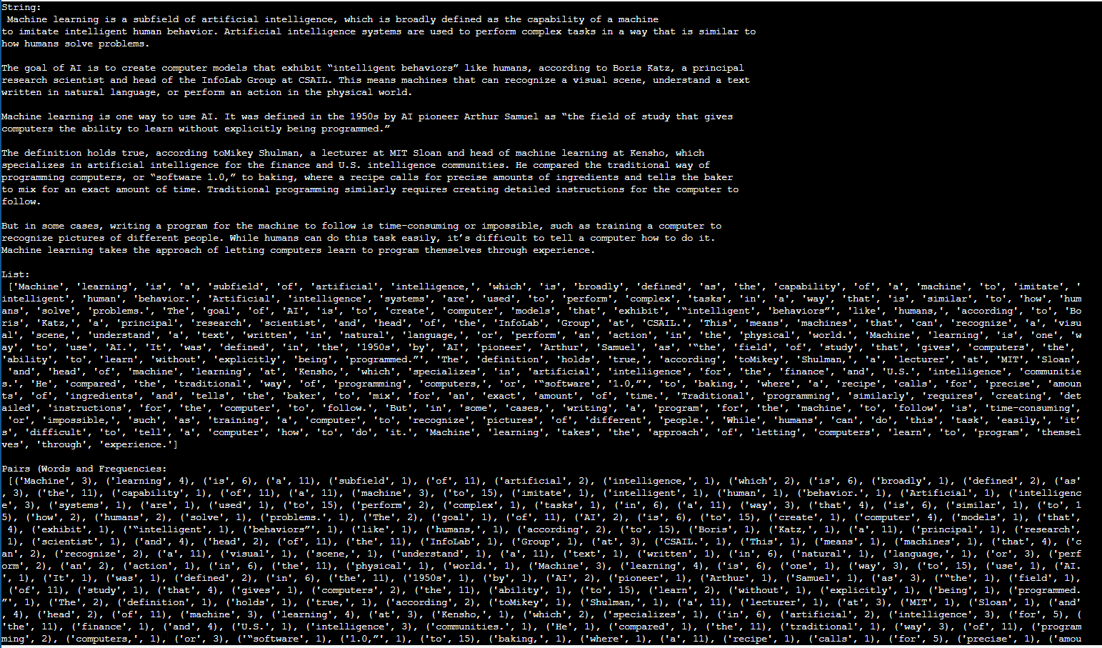

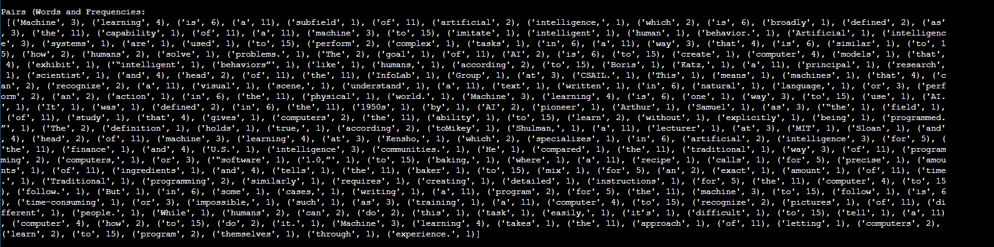

1. **Write a Python program to count the number of each character in a text file.**

**CODE: -**

import collections

import pprint

file_input = input('File Name: ')

with open(file_input, 'r') as info:

count = collections.Counter(info.read().upper())

value = pprint.pformat(count)

print(value)

print("\nTharun Peram, AP20110010801")

**Screenshots of OUTPUT: -**

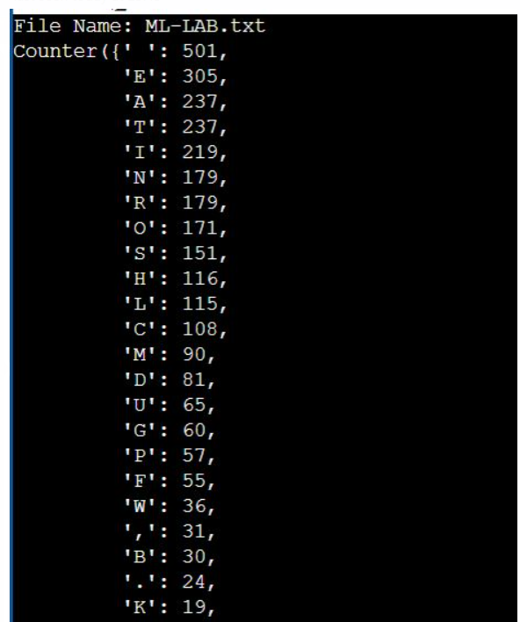

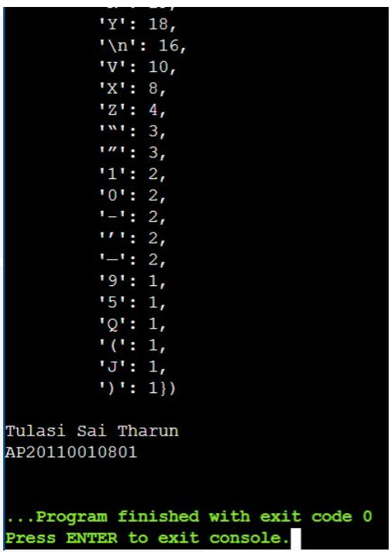

1. **Write a Python program that retrieves the top stories from Google News.**

**CODE: -**

import bs4

from bs4 import BeautifulSoup as soup

from urllib.request import urlopen

news_url="https://news.google.com/news/rss"

Client=urlopen(news_url)

xml_page=Client.read()

Client.close()

soup_page=soup(xml_page,"xml")

news_list=soup_page.findAll("item")

# Print news title, url and publish date

for news in news_list:

print(news.title.text)

print(news.link.text)

print(news.pubDate.text)

print("-"*60)

print("\nTharun Peram, AP20110010801")

1. **Write a Python program to get a list of locally installed Python modules.**

**CODE: -**

import pkg_resources

installed_packages = pkg_resources.working_set

installed_packages_list = sorted(["%s==%s" % (i.key, i.version)

for i in installed_packages])

for m in installed_packages_list:

print(m)

print("\nTharun Peram, AP20110010801")

**Screenshots of OUTPUT: -**

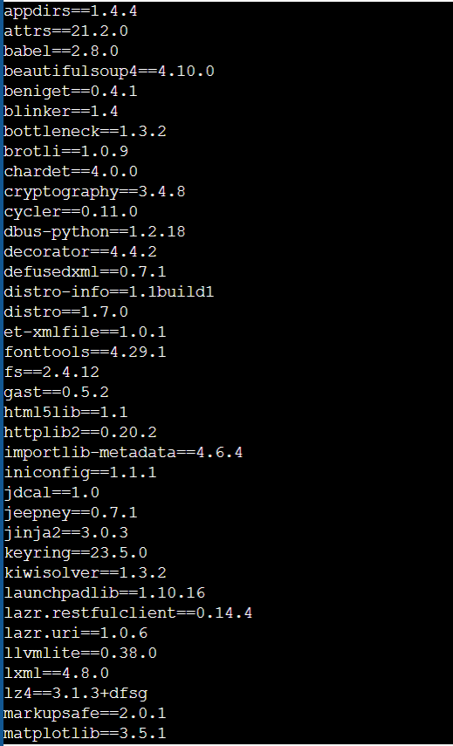

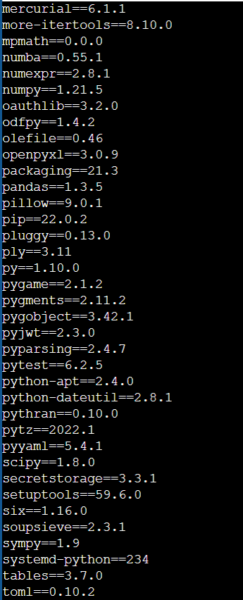

1. **Write a Python program to display some information about the OS where the script is running.**

**CODE: -**

**import platform as pl**

os_profile = [

'architecture',

'linux_distribution',

'mac_ver',

'machine',

'node',

'platform',

'processor',

'python_build',

'python_compiler',

'python_version',

'release',

'system',

'uname',

'version',

]

for key in os_profile:

if hasattr(pl, key):

print(key + ": " + str(getattr(pl, key)()))

print("\nTharun Peram, AP20110010801")

**Screenshot of OUTPUT: -**

